Using the Journal of Physics: Conference Series Word templates
- How to use the template
To create a new document simply store the template in a convenient location and double-click it.
- Applying paragraph styles
The template also contains a number of predefined paragraph styles (see table 1) which can be accessed quickly and conveniently using the toolbar provided. To format a paragraph in a particular style simply click on the appropriate style name in the Paragraph Styles toolbar.

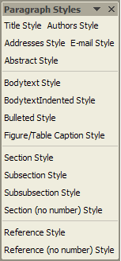 | The Paragraph Styles toolbar enables you to quickly and conveniently apply paragraph styles. See table 1 for examples of each style.
  - Showing the Paragraph Styles toolbar
To display the Paragraph Styles toolbar click on ‘Show Paragraph Styles’ in the menu bar. Please note that you will need to have macros enabled before this command will work.

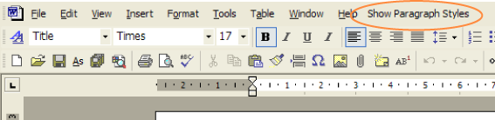

- Sample text
The document created from the template contains some text to help you start formatting your paper, simply delete the text provided and replace it with your own.

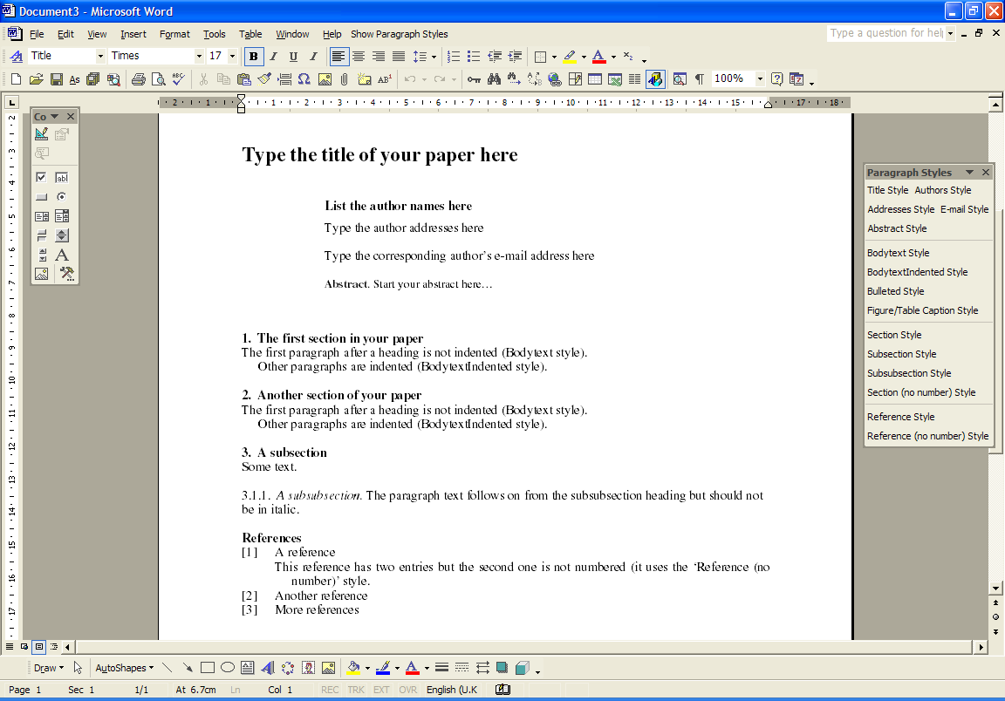

- Predefined paragraph styles
Table 1 lists the paragraph styles defined in the Journal of Physics: Conference Series template.

Table 1. Paragraph styles defined in the Journal of Physics: Conference Series templates.
Style | Example and use
Abstract | Style in which to format your Abstract
Addresses | Style for author addresses
Authors | Style for the list of author names
Bodytext | The style for the first paragraph after a section, subsection or subsubsection
BodytextIndented | An indented style for paragraphs that follow after Bodytext
Bulleted | - Bulleted list
E-mail | Style for corresponding author’s e-mail address
FigureCaption | Centred figure (and table) caption style
Reference | - The style to use for a numbered reference. Note that when the text reaches the end of the line it will indent slightly
Reference (no number) | A style for references that are part of a numbered reference (where there are multiple entries under a single number)
Section | - Style for section headings
Section (no number) | Style for section headings that are not numbered (e.g., ‘References’)
Subsection | - Style for a subsection
Subsubsection | - Style for subsubsection. Type a full stop (‘period’) after the heading text and continue the paragraph in Roman (upright) type
Title | The title of your paper

